**terraform-template-task**

***1) Create VPC***

**>>create a directory with name** terraform-x **and add a file** main.tf **then add the template**

provider "aws" {

  region = "us-east-2"

}

resource "aws_vpc" "main" {

  cidr_block = "192.168.0.0/24"

  tags = {

    Name = "terraform-vpc"

  }

}

**🡪 crl+s**

**#** terraform init > terraform plan > terraform apply **<check on console if its created>**

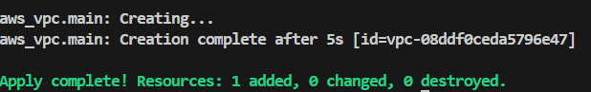 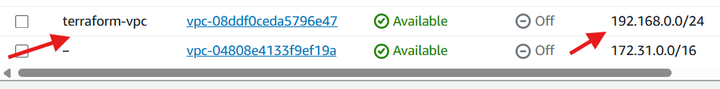

***2) Create Internet gateway***

**>>add this template to exixting** main.tf **file**

resource "aws_internet_gateway" "gw" {

  vpc_id = aws_vpc.main.id

tags = {

    Name = "terraform-gw"

  }

}

**🡪 crl+s**

**#** terraform init > terraform plan > terraform apply **<check on console if its created>**

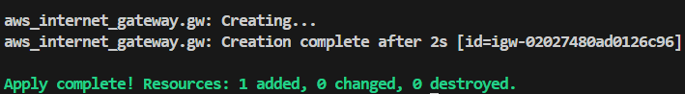 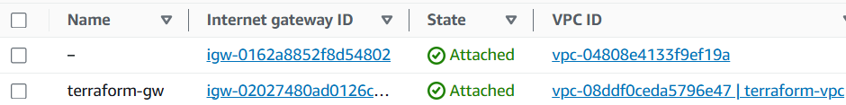

***3) Create Custom Route Table***

**>>add this template to exixting** main.tf **file**

resource "aws_route_table" "rt" {

  vpc_id = aws_vpc.main.id

  route {

    cidr_block = "0.0.0.0/0"

    gateway_id = aws_internet_gateway.gw.id

  }

tags = {

    Name = "terraform-rt"

  }

}

**🡪 crl+s**

**#** terraform init > terraform plan > terraform apply  **<check on console if its created>**

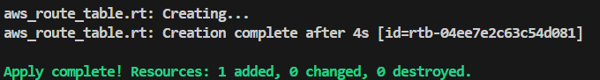 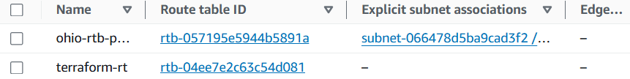

***4) Create Subnet***

**>>add this template to exixting** main.tf **file**

resource "aws_subnet" "subnet" {

  vpc_id    = aws_vpc.main.id

  cidr_block = "192.168.0.0/28"

  availability_zone = "us-east-2a"

  tags = {

    Name = "terraform-subnet"

  }

}

**🡪 crl+s**

**#** terraform init > terraform plan > terraform apply  **<check on console if its created>**

**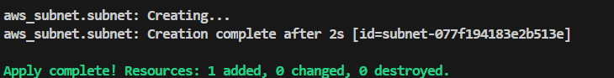 *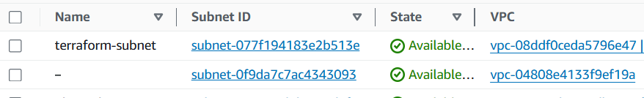***

***5) Associate subnet with Route Table***

**>>add this template to exixting** main.tf **file**

resource "aws_route_table_association" "a" {

  subnet_id      = aws_subnet.subnet.id

  route_table_id = aws_route_table.rt.id

}

**🡪 crl+s**

**#** terraform init > terraform plan > terraform apply  **<check on console if its created>**

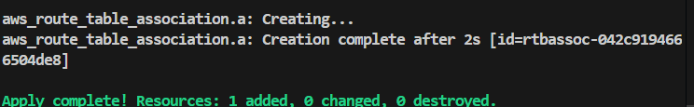 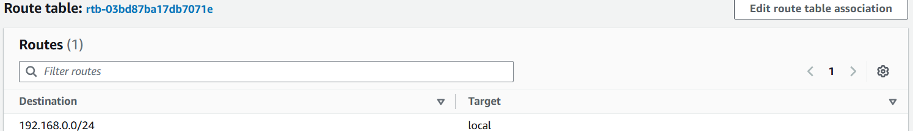

***6) Create Security Group to allow port 22,80,443***

**>>add this template to exixting** main.tf **file**

resource "aws_security_group" "sg" {

vpc_id = aws_vpc.main.id

ingress {

from_port = 22

to_port = 22

protocol = "tcp"

cidr_blocks = ["0.0.0.0/0"]

}

ingress {

from_port = 80

to_port = 80

protocol = "tcp"

cidr_blocks = ["0.0.0.0/0"]

}

ingress {

from_port = 443

to_port = 443

protocol = "tcp"

cidr_blocks = ["0.0.0.0/0"]

}

egress {

from_port = 0

to_port = 0

protocol = "-1"

cidr_blocks = ["0.0.0.0/0"]

}

tags = {

Name = "main-sg"

}

}

**🡪 crl+s**

**#** terraform init > terraform plan > terraform apply  **<check on console if its created>**

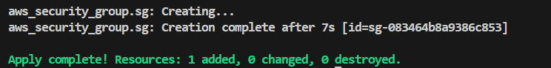 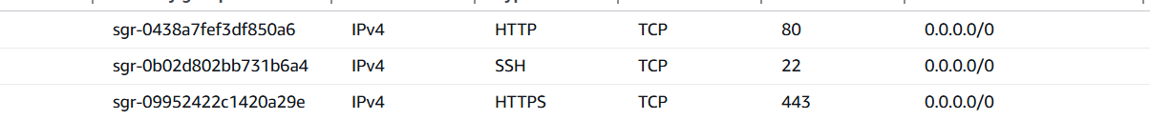

***7) Create a network interface with an ip in the subnet that was created in step 4***

**>>add this template to exixting** main.tf **file**

resource "aws_network_interface" "eni" {

  subnet_id       = aws_subnet.subnet.id

  private_ips     = ["192.168.0.12"]

  security_groups = [aws_security_group.sg.id]

tags = {

    Name = "terraform-eni"

  }

}

**🡪 crl+s**

**#** terraform init > terraform plan > terraform apply  **<check on console if its created>**

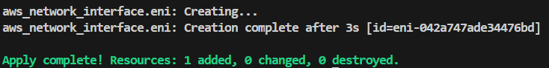 

***8) Assign an elastic IP to the network interface created in step 7***

**>>add this template to exixting** main.tf **file**

resource "aws_eip" "eip" {

  vpc               = true

  network_interface = aws_network_interface.eni.id

  tags = {

    Name = "terraform-eip"

  }

}

**🡪 crl+s**

**#** terraform init > terraform plan > terraform apply  **<check on console if its created>**

 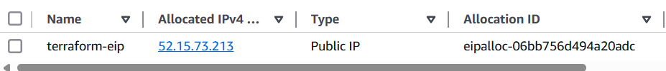

***Note:***

***1) Create single main.tf which will be created the above resources and do not hardcode the id's.***

***9) Create Ubuntu server and install/enable apache2***

**>>add this template to exixting** main.tf **file**

resource "aws_instance" "web" {

  ami           = "ami-036841078a4b68e14"

  instance_type = "t2.micro"

  network_interface {

    network_interface_id = aws_network_interface.eni.id

    device_index         = 0

  }

  user_data = <<-EOF

              #!/bin/bash

              sudo apt-get update -y

              sudo apt-get install -y apache2

              sudo systemctl start apache2

              sudo systemctl enable apache2

              EOF

  tags = {

    Name = "terraform-server"

  }

}

output "instance_public_ip" {

  value = aws_instance.web.public_ip

}

**🡪 crl+s**

**#** terraform init > terraform plan > terraform apply  **<check on console if its created>**

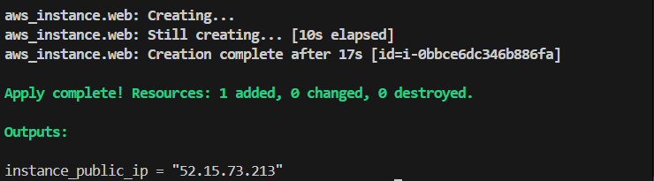 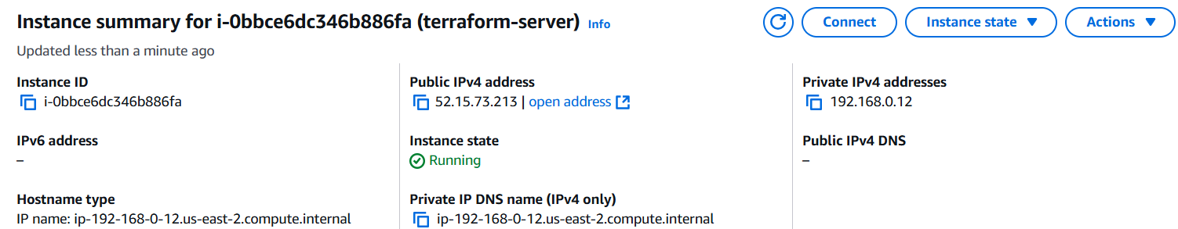

**<checking if the apache is installed and running by using public ip** [*http://52.15.73.213:80*](http://52.15.73.213:80)***>***

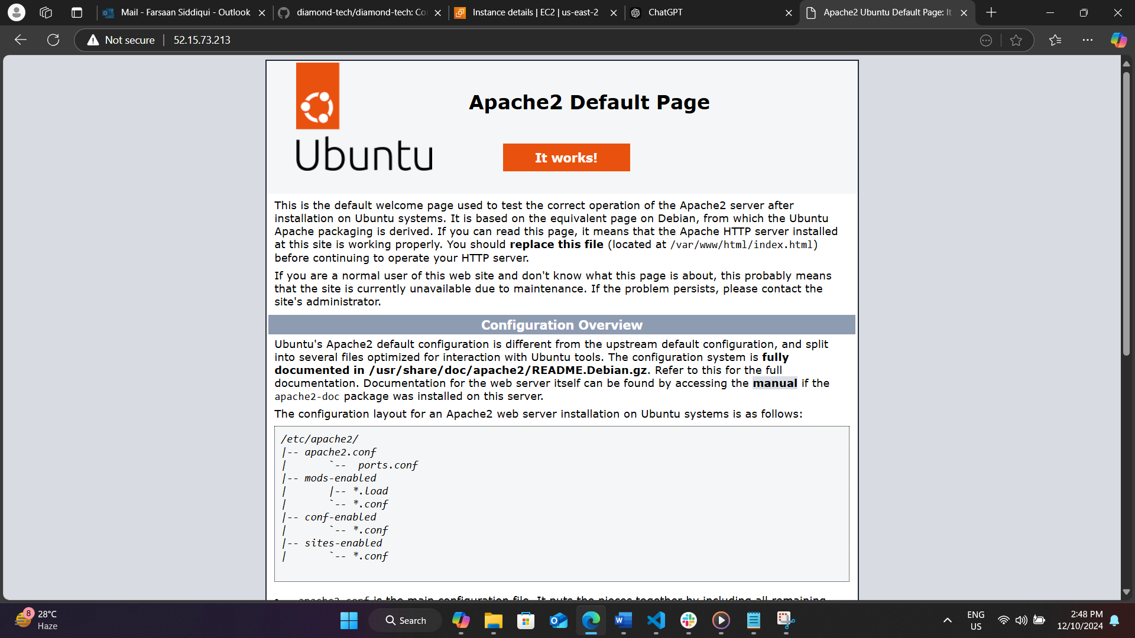

**Configure s3 as backend and dynamo db locking for multi user execution.**

**🡪creating a s3 bucket and dynamo db**

**>>add this template to exixting** main.tf **file**

resource "aws_s3_bucket" "terraform_state" {

  bucket = "terraform-task-bucket"

  acl    = "private"

}

resource "aws_dynamodb_table" "terraform_state_lock" {

  name         = "terraform-task-dynamodb"

  hash_key     = "LockID"

  read_capacity  = 20

  write_capacity = 20

  attribute {

    name = "LockID"

    type = "S"

  }

}

**🡪 crl+s**

**#** terraform init > terraform plan > terraform apply

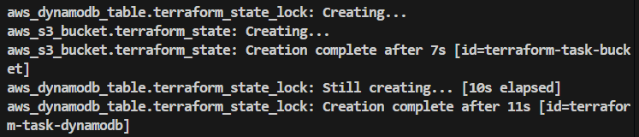

**🡪configuring s3 as backend and dynamodb locking**

**>>add this template to exixting** main.tf **file**

terraform {

  backend "s3" {

    bucket         = "terraform-task-bucket"

    key            = "terraform.tfstate"

    region         = "us-east-2"

    dynamodb_table = "terraform-task-dynamodb"

    encrypt        = true

  }

}

**🡪 crl+s**

**#** terraform init > terraform plan > terraform apply

